Park View Project (Digital Inclusion North Tyneside)
NTDF Centre, Earsdon Road, Shiremoor, Newcastle upon Tyne, NE27 0HJ
Charity number 1196503

Annual General Meeting 29th March 2023
1. Name
The name of the Charitable Incorporated Organisation (“the CIO”) is
Park View project
2. location of principal office
C/O NTDF Centre
Earsdon Road, Shiremoor
Newcastle upon Tyne
Tyne & Wear
England
NE27 0HJ
3. Object[s]
The objects of the CIO are:
To promote social inclusion for the public benefit by preventing people from becoming socially excluded, relieving the needs of those people who are socially excluded and assisting them to integrate into society in particular but not exclusively by improving their digital skills and in such other ways as the trustees consider appropriate. For the purpose of this clause ‘socially excluded’ means being excluded from society, or part of society, as a result of being a member of a socially and economically deprived community.

4. Trustees:
Ann Craven
Helen Dawson
Sue Adams
Martin Lee
Simon Schofield
Vicki Peacock
Appointment of charity trustees
(1) Apart from the first charity trustees, every trustee must be appointed [for a term of three years] by a resolution passed at a properly convened meeting of the charity trustees.
(2) In selecting individuals for appointment as charity trustees, the charity trustees must have regard to the skills, knowledge and experience needed for the effective administration of the CIO.
Retirement and removal of charity trustees
(1) A charity trustee ceases to hold office if he or she:
(a) retires by notifying the CIO in writing (but only if enough charity trustees will remain in office when the notice of resignation takes effect to form a quorum for meetings);
(b) is absent without the permission of the charity trustees from all their meetings held within a period of six months and the trustees resolve that his or her office be vacated;
(c) dies;
(d) in the written opinion, given to the company, of a registered medical practitioner treating that person, has become physically or mentally incapable of acting as a director and may remain so for more than three months;
(e) is disqualified from acting as a charity trustee by virtue of sections 178-180 of the Charities Act 2011 (or any statutory re-enactment or modification of that provision).
(2) Any person retiring as a charity trustee is eligible for reappointment.
(3) A charity trustee who has served for three consecutive terms may not be reappointed for a fourth consecutive term but may be reappointed after an interval of at least one year.
Bankers: Barclays Bank, Whitley Bay branch.
Aims:
1. Enable residents of North Tyneside to manage day-to day household tasks using digital media and internet products. (All makes and models including managing a variety of social media sites: Tumblr, Instagram, Twitter, Facebook, LinkedIn, Pinterest etc.,)
2. Enable beneficiaries to manage their own lives more easily and more effectively, and to pursue their own goals and aspirations via an online presence.
3. Enable users to identify with and support each other both online & offline via our website Forums and live chat.
4. Promote personal development by tackling isolation and increasing confidence, motivation, and self-esteem and skills via our online Community Reporter Learning Programme’.
6. Increase opportunities for volunteering via our Online Chums volunteering programme where volunteers mentor people with a variety of support needs.
7. Support for our volunteers and beneficiary’s by promoting personal development portfolios, which represent experience and competencies achieved throughout their time with the project.
8. Cyber awareness and anti-bullying strategies actively discussed in a social setting using Park View Projects e-platforms and how to support others who have experienced online abuse.
11. Access to many independent projects such as WW1 – The Bigger Picture and “Working with Older People and the Digital Divide, which all have a digital emphasis.
12. Have available a large IT suite with PC’s, loan library and access to Apple mac desktop computers support. There is separate support for those who only need to access PC for specific uses such as CV, benefit applications or applying for a job (All data secure and governed by 1998 Data Protection Act).
13. Access to online and offline digital learning tools, such as Learn My Way.
Agenda:
Present: Vicki Peacock (Chair), Bob Dennis (Project Manager), Ann Craven, Martin Lee, Mrs Sue Adams, Simon Schofield, Helen Dawson, Robert Dixon.
Apologies: Mrs Sue Adams.
Adoption of previous year’s AGM minutes: All present agreed. Seconded by Ann Craven and Simon Schofield.

Accounts: Please see separate entry.

Who do we Represent:

Our project is about drawing attention to the social & economic challenges that many face because of the rapid digital transformation of society and the subsequent automation that is widely found in everyday life. This is affecting many in ways that have not been fully documented by policy makers nor is readily acknowledged by many businesses, whose expectations are that customers default to accessing their services online.
Many older and disabled residents are experiencing a technologically driven world that is challenging their independence because many household tasks now require access to the internet, and with the increasing roll out of automation of day-to-day interactions such as car parking to telephone communication systems, many are feeling disenfranchised. This is further compounded by a reduction of informal information hubs such as post offices, local access to libraries, corner shops where locals stopped for a ‘catch up’. These community connections are gradually being eroded and being replaced by online access.
The impact cannot be underestimated for those whose first ‘language’ is not digital, and who are not conversant with using online services and are, in many cases, resistant to learning because of the media’s horror stories of cybercrime. Moreover, the acceleration of social media language in a fast-paced virtual space, only adds to the bewilderment that many experience.
Other groups affected by the dominance of the internet are those who have experienced Hate Crime, where disabled people are disproportionately represented. Contrary to what we are told, online abuse is not a priority for internet-based services because they cannot moderate effectively. Secondly, young people are often caught up in the web of cyber bullying, which again, is very difficult to police because much of this goes under the radar of parents/guardians and social media companies until it is usually too late.
Many individuals are classified as living in poverty, which because of their status, have no access to managing the demands services placed on them. There are those who are required to apply for work to retain DWP help, which we know from research undertaken, affects many families across the borough. Many don’t have easy access to computers and a considerable number have little competency required to complete both online benefit applications as well as the demands of providing evidence that they are applying for jobs.
There is a fourth grouping made up of ex-services personnel who are challenged by technology because it has not been a central to their roles in armed forces, where many have only seen conflict; refugees whose English language is not there first language with no access to mobile products. They experience a sense of feeling overwhelmed; even where technology can translate English into their own language it is still fraught with misunderstanding because of cultural differences. Furthermore, these groups experience the same challenges as residents who live in poverty with little competencies in using internet-based services.
And lastly, Disabled people of all ages can be grouped as one because often it is the barriers to digital access that is the common denominator. Digital technology has come a long way from the early incarnations designed for the ‘abled’ rather than with features supporting those with sensory/physical and intellectual disabilities. Many of the solutions are readily found hidden away in operating systems such as Microsoft tools, where some simple adaptations can make all the difference. However, assistive technology is the obvious remedy to those who need more than the quick fix. Having trusted sources to investigate your needs is vital in making available assistive technology available. Unfortunately, for many we work with, this technology is a step to far because of cost. Aware of the limitations our project is working towards introducing access to the potential of assistive technology using a variety of approaches. Our Digital First Aid incorporates access to information and potential temporary loans for people to try before they buy as well as provide a safe space to use access technology during visits to our drop-in sessions – this is an ongoing development.
Vicki Peacock (Chair Park View Project)
Executive Summary:
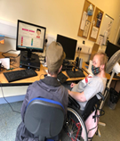
During the lockdowns we established a variety of ways to stay connected to our users, which we have now adopted more widely. One such example is a piece of software called Team Viewer. The TeamViewer provides remote connectivity using a cloud-based platform that enables secure remote access to any device, across platforms, from anywhere, anytime. TeamViewer connects computers and smartphones. This meant we could easily help someone to set up their digital device. The only thing they need is to be able to turn on the device with access to an email account. Secondly, we continued to use all non-digital channels such as telephone and we have made printed material available to ensure that nobody missed out on information on up-and-coming events, local information about where to get help, etc.

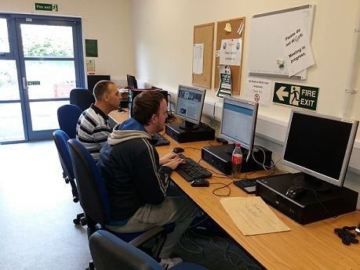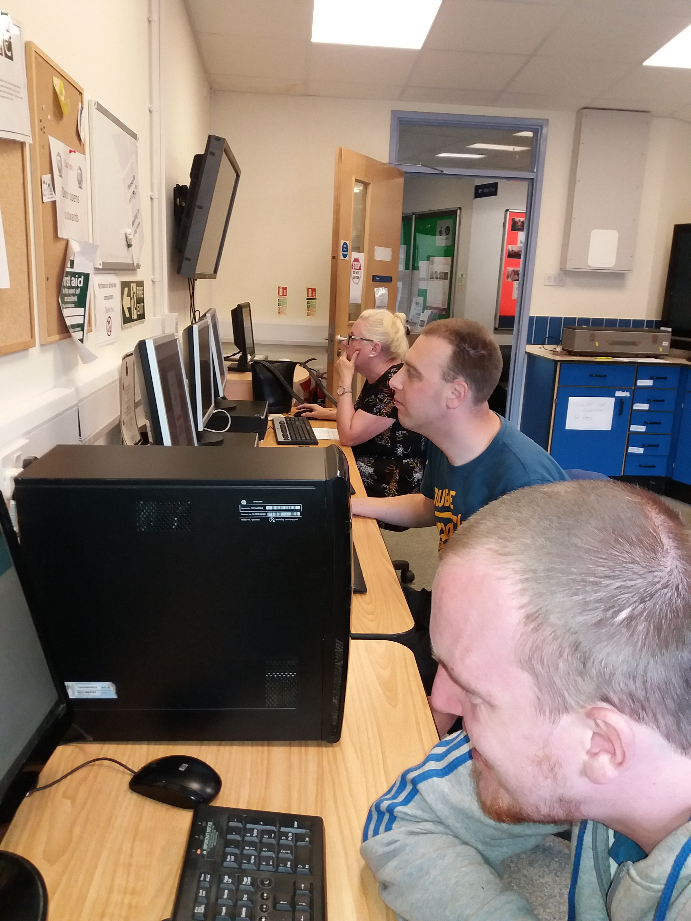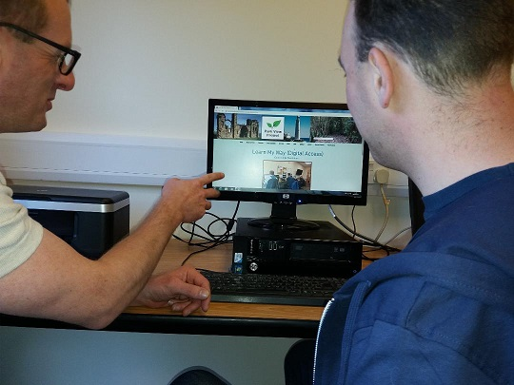
Volunteer recruitment:
We are actively seeking volunteers to become Online Chum Mentors. You can find out about this role via our website: https://www.parkviewprojectne.com/volunteer
We are especially interested in locating residents of the borough with skills of website management/design/content relating to Wix web platform and someone with writing skills who can translate ‘how to’ instructions for people with little or no digital skills, i.e., basic use of android/apple, Phones/iPad. If you want to know more, you can contact Bob on 0191 466 1667 or email office@parkviewproject.org.uk Link to volunteer recruitment application and opportunities: Volunteer application form
Revamping of our drop-in service:
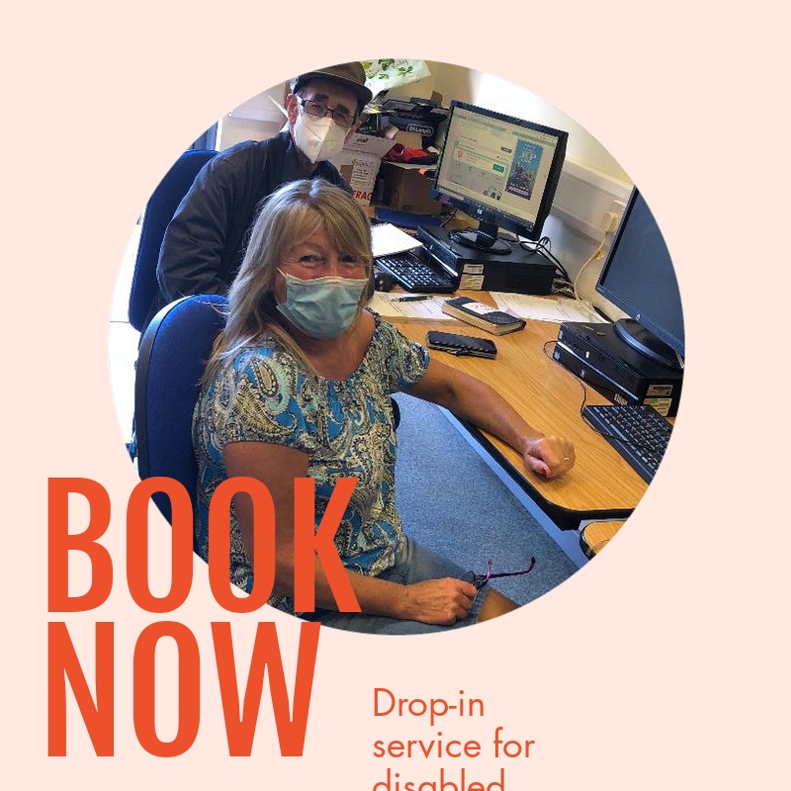
We have taken possession of new mini desktops to compliment already available hardware including a recent edition of a mac desktop, alongside tablets and iPads that can be used for learning purposes. We also have on order new pieces of Assistive Technology such as head pointers, track ball mice and roller balls. These devices will help those with physical disabilities to access online services/activities easier. We have also acquired two Apple Mac desktops, one new made possible by DWF Foundation and one older machine donated by a volunteer Peter Glaves.
Future goals:
We are researching how to become the first centre to adopt the status of Digital Accessible Hub. Here is the link to the proposals, which are featured on our website Digital First Aid - Future developments Digital First Aid objectives:
- ​To enable people with disabilities, older and those digitally excluded to access assistive technology to get online.
- ‘Digital First Aid’ training delivered by disabled people for disabled people
- Improve health, self-care, and choice for all disenfranchised on the digital periphery.
- North Tyneside community will promote and enable positive health, wellbeing, and independence in North Tyneside through increased access to digital health technology.
Reboot Scheme:
Our role in addressing affordability of digital items and connectivity has led us to evaluate the possibilities of establishing a local Reboot Scheme, which would allow local recycling of digital items. This has a social and economic community benefit because it would raise public awareness of those on the digital periphery, and as a valuable asset in developing a local focus that show-cases community self-help initiatives taking place in North Tyneside: Here is a link to the Reboot Scheme https://rebootproject.uk/ Or download from our website: https://www.parkviewprojectne.com/rebbot-scheme
Use of interactive games as a tool for digital learning:
Alternative learning strategies that make teaching basic digital skills interesting and entertaining will involve for example Train Sim World Two, which involves suing not only digital navigating but importantly cognitive and coordinating skills that help with managing a variety of online apps. Take a look and see what you think: Train Sim World Two We are also looking to identify online word games, which amount to more than playing just for fun but can help with literacy, language development as well as coordinating and navigational skills.
Donations 2022/23:
DWF Foundation, RW Mann Trust, Awards for All, with income from North Tyneside Disability Forum Training Services. Total funds for 2022: £19,585. Please see accounts for details of donor funding and income generation.
Access to on-site café facilities:
Following closure owing to the pandemic access to this facility will be available to volunteers and users of our drop-in services. The café should be opening in stages with only Thursday afternoons so far scheduled. However, Tuesday and Wednesdays should be available to our project over the coming months.
Any other business: There was none.
Close of meeting 7.00 pm.
.
Signed: Mrs Vicki Peacock (Chair of the board of trustees).

